Battery charger
This activity requires the fabrication and assembly of a battery charger.

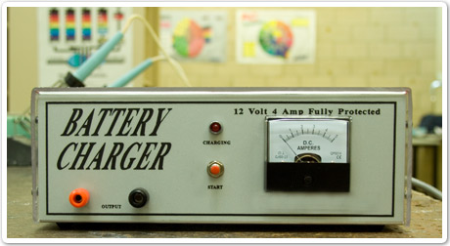

Preparation
Access the following equipment and components:
- sheet metal
- battery charger components (see component list at end of this Word document)
- hand tools including; scriber, ruler, punch, hammer, screwdrivers
- equipment including; drills and drill press, folding machine, soldering equipment, hole cutter.
Or
Discuss with your trainer alternative parts and equipment.

Marking out
Mark out the sheet metal following the drawing plan at the end of this Word document.
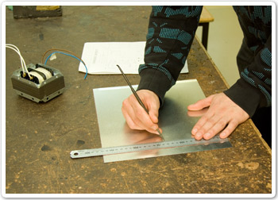 | 

Create holes
Lightly punch drill positions then use appropriate sized drill bits and press to drill holes.
 | 

Use a hole cutter or hole saw to create hole for ammeter. File out holes where necessary to fit components.
 | 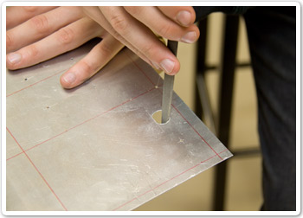

Cut and bend metal
Use a tin snips to cut metal then bend using a folding machine.
 | 

Assemble circuit board
Check all componentry against the list, then fit and solder to circuit board.
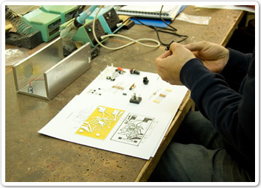 | 

Wind transformer and assemble charger
Follow your trainer’s directions to wind transformer. Assemble components in charger box and test.
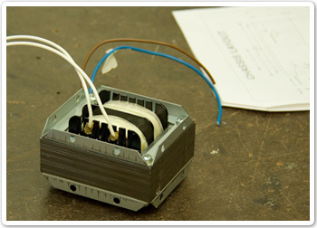 | 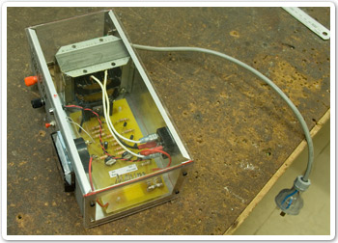

Check work
Present your completed battery charger to your trainer for feedback.
Clean up your work area and replace tools and equipment.

Drawing plan
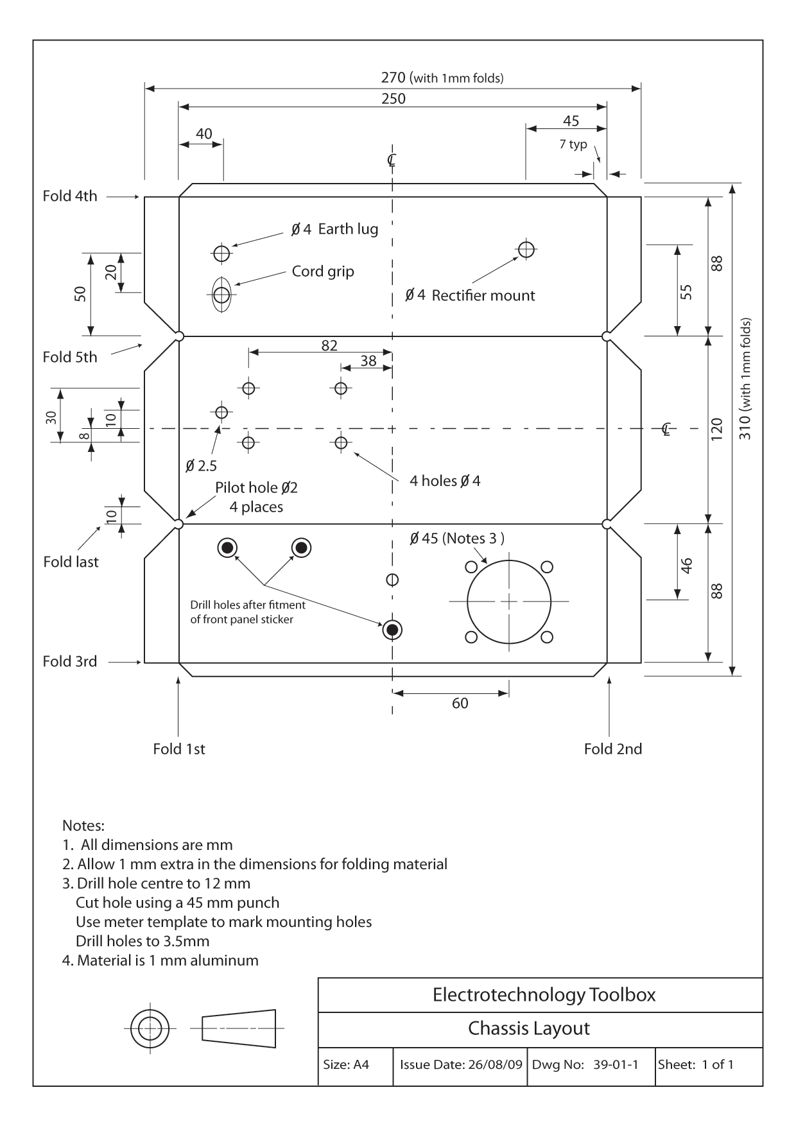

Wiring diagram
